RAC INCORPORATED
Craig Engel, General Contractor
1267 N 1390 W, Saint George, UT 84770 | (435) 229-7360 | racinc19@gmail.com

CHANGE ORDER CO-006
Hose Bibs & Electrical Additions — No Cost Change
Project: | Rodriguez Residence – Oak Valley Estates Lot 5 | Date: | February 25, 2026
Owner: | Mr. & Mrs. Rodriguez | CO Number: | CO-006
Location: | Liberty Lane, Kanarraville, UT 84742 | Contract Value: | $0.00 — No Cost

NO COST CHANGE ORDER: This change order adds scope to the contract at no additional cost to the Owner. Contract sum remains unchanged.

SCOPE SUMMARY

Item | Description | Qty | Cost
Hose Bibs — Upper Level | Add 2× frost-free hose bibs at upper level exterior per plan | 2 | $0.00
Duplex Outlets — Panic Room | Add 2× 120V duplex outlets in basement panic room | 2 | $0.00
1. Add 2× Frost-Free Hose Bibs — Upper Level Exterior [ADD — NO COST]

Two frost-free hose bibs are added to the upper level exterior at locations indicated on the plan. Hose bibs to be frost-free sillcock type, connected to domestic cold water supply. Locations shown on upper level plan below.
Item | Frost-free exterior hose bib (sillcock)
Quantity | 2 units
Floor | Upper level exterior
Connection | Domestic cold water supply
Type | Frost-free sillcock with vacuum breaker
Locations | Per upper level plan — see reference below
Cost | No cost — included in base contract scope

Plumbing contractor to coordinate exact penetration locations with GC prior to rough-in. Verify insulation and air sealing at each wall penetration.

Reference — Upper Level Plan showing Hose Bib Locations (HB):
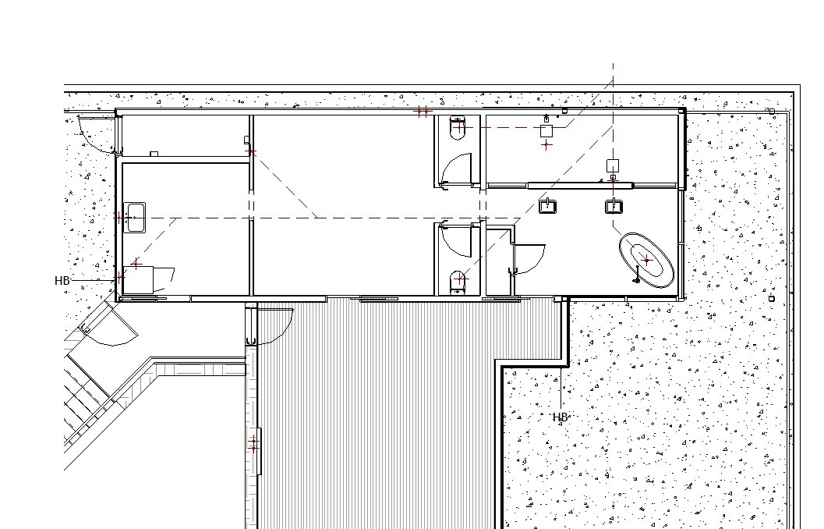
2. Add 2× Duplex Outlets — Basement Panic Room [ADD — NO COST]

Two 120V duplex outlets are added inside the basement panic room. Outlets to be standard 20A duplex receptacles on dedicated circuit. Locations to be confirmed at field walk with GC. Plan reference shown below.
Item | 120V 20A duplex receptacle
Quantity | 2 units
Floor | Basement — Panic Room
Circuit | Dedicated 20A circuit per NEC
Height | Standard AFF unless noted otherwise by GC
Locations | Per electrical plan — see reference below
Cost | No cost — included in base contract scope

Electrical contractor to coordinate outlet locations with GC prior to rough-in. Confirm circuit sizing and panel assignment with electrical engineer of record.

Reference — Basement Panic Room Plan showing Outlet Locations:
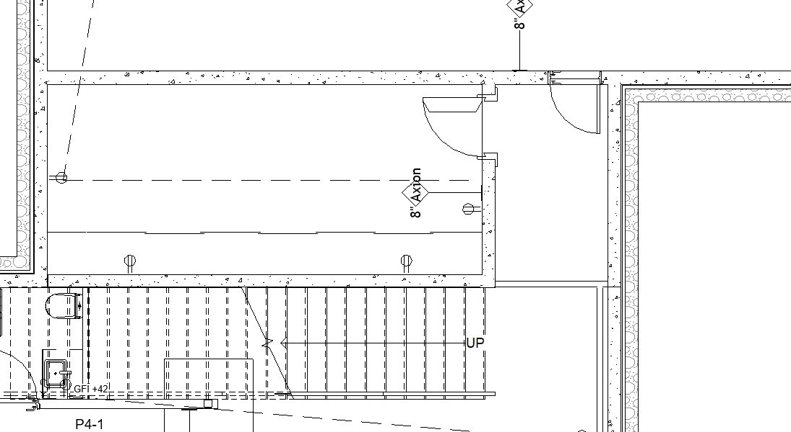

AUTHORIZATION & OWNER APPROVAL

By signing below, Owner authorizes RAC Incorporated to proceed with the scope of work described in Change Order CO-006. This change order is issued at no additional cost to the Owner. This change order becomes part of the contract documents upon execution.
Craig Engel — RAC Incorporated |  | Owner — Rodriguez Residence
General Contractor |  | Date: ___________________

